Server

&

Software Architecture

Server

Also called Tier or Layer. Server is device which serves services to end user such as websites, managing databases, running applications, storing files. We have 3 types of servers

Types of Servers:

1. Web Server/Web Tier/Web Layer.
2. App Server/App Tier/App Layer.
3. Database Server/Database Tier/Database Layer.

1) Web Server/Web Tier/Web Layer:

It also called Presentation layer. web server's job is to take your request for a website, find the website, and send it back to you so you can see it in your browser.

To show the application we need who works on it:

Front-End Developers, UI/UX Developers.

What they use:

HTML, CSS, JavaScript

2) App Server/App Tier/App Layer:

It also called logic layer. An application server is like a powerful computer that runs software applications and handles the behind-the-scenes work when you use an app.

Who works on it:

Backend Developers.

What they use:

Java, Python, C, C++, .NET, Go…

3) Database Server/Database Tier/Database Layer:

It also called Database Layer. Database server is like a powerful computer that keeps all your data organized and provides it to applications whenever they need it. Such as ticket details on any site most of times movie tickets.

Who works on it:

Database Admins

What they use:

SQL, Oracle, Postgres, Arango…

Simple Explanation of the three Servers

1) When you google ‘bookmyshow’ and open main website it will show like this



now this is this show because of Web Server/Web Tier/Web Layer

if there was no web server this page will be not presented.

2) Now When you Click any Button on that Website it will perform Specific Action and that is Because of App Server/App Tier/App Layer. Mean That action is occur cause of App Server/App Tier/App Layer

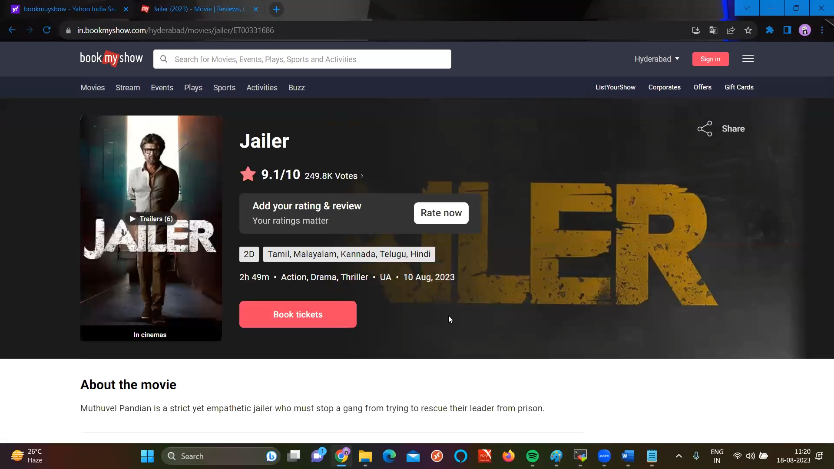

3) Now if you click ‘book tickets’ button they it will show all the booked seats and movie timing (pm or am) location and also details about the date of movie and ticket price and that all information’s show because of Database Server/Database Tier/Database Layer

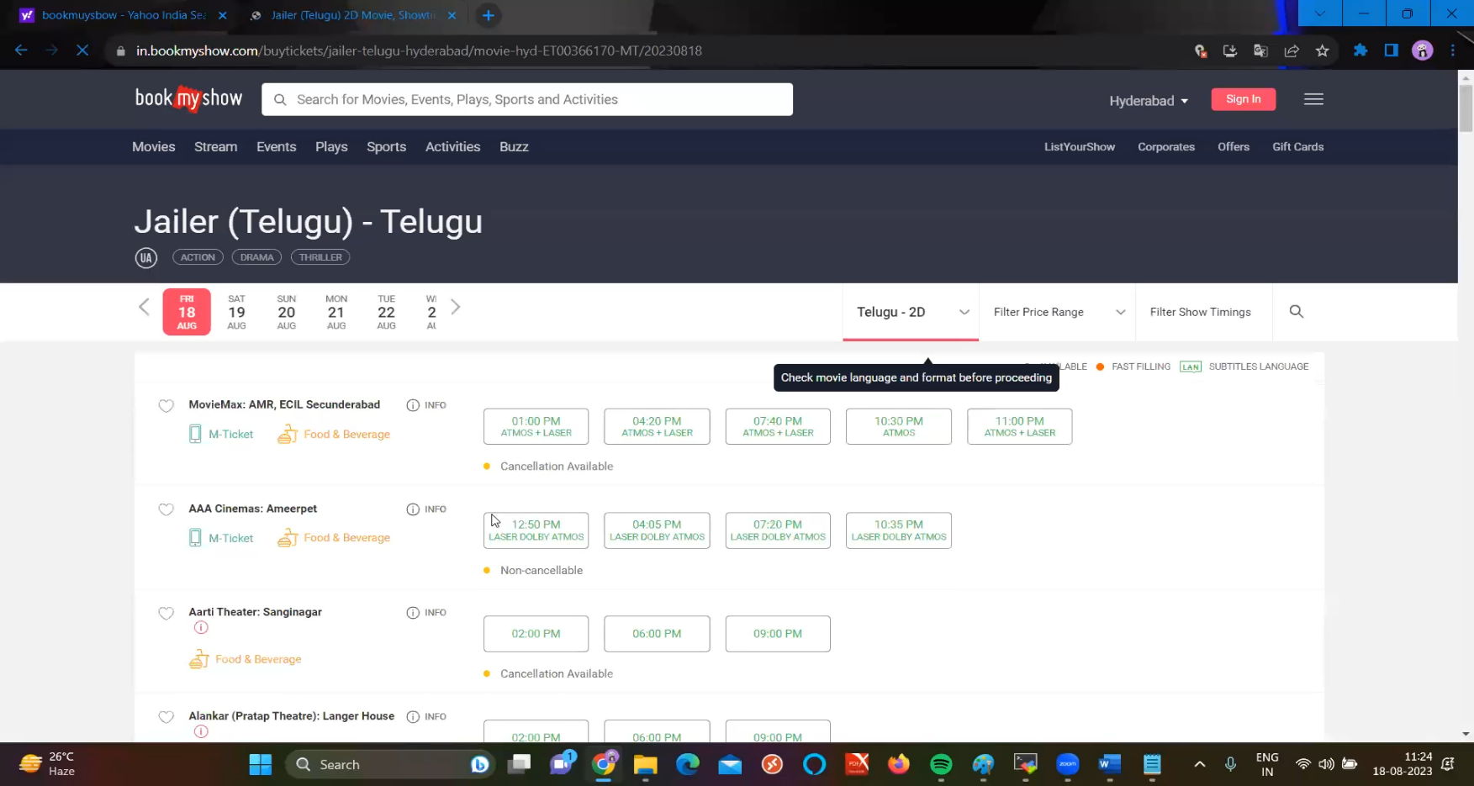

Software Architecture

It shows how the different parts of the software fit together and how they interact with each other.

Types:

1. One Tier-Architecture
2. Two Tier-Architecture
3. Three Tier-Architecture
4. N Tier-Architecture

1) One Tier-Architecture:

One tier-architecture also called standalone application is like having everything (Web Server, App Server, Database Server) if needed in one place on a single computer. It’s easy to set up and use for small, simple applications, but not ideal for larger, more complex systems that require scalability and flexibility.

Example:

Microsoft Word or a simple database application that runs entirely on a single PC without needing a server or an internet connection.

2) Two Tier-Architecture:

Two-tier architecture also known as client-server architecture, is a software design pattern where an application is divided into two parts: the client and the server. This separation allows for better organization and management of resources, especially when compared to a single-tier architecture.

Example:

**Client** A desktop application for managing customer orders.

**Server** A database server that stores customer data, order information, and inventory details.

3) Three Tier-Architecture:

In simple terms, a three-tier architecture divides an application into three layers: the user interface (Presentation layer/Web Server), the core functionality (Logic layer/Application layer), and the data management (Database layer/Database Server). This structure helps make the application more modular, scalable, and easier to maintain.

Example:

WhatsApp, Instagram etc. Simply you can suppose that the three layers will work like this!

**Presentation Layer** The web interface where users browse products, add items to their cart, and check out.

**Application Logic Layer** The server-side logic that handles user authentication, processes order, manages inventory, and calculates totals.

**Data Layer** The database that stores user profiles, product details, order history, and inventory levels.

4) N Tier-Architecture:

N-tier architecture also known as multiple layer architecture is scalable approach to building applications by dividing them into multiple layers, each with a specific responsibility.

Example:

e-commerce platform. Simply you can suppose that the t layer will work like this!

**Presentation Layer** The web interface where users browse products, add items to their cart, and check out.

**Business Logic Layer** The server-side logic that handles user authentication, processes order, manages inventory, and calculates totals.

**Data Access Layer** The layer that converts business logic requests into database queries.

**Data Layer** The database storing user profiles, product details, order history, and inventory levels.

**Integration Layer** Interacts with payment gateways and shipping services.

**Caching Layer** Stores frequently accessed product information to speed up response times.

**Security Layer** Manages user authentication and data encryption.